Welcome guide for exchange students



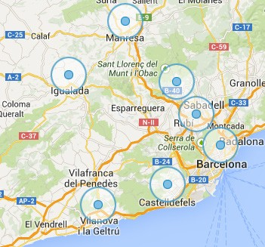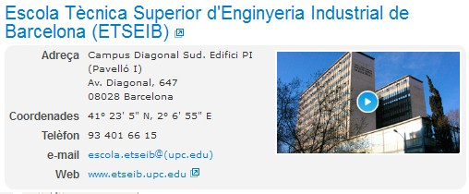
Palau Reial

Zona Universitària

 |  |  | Academic info & Welcome activities for incoming and master’s students | --> ETSEIB International Office  incoming.etseib@upc.edu; +34 93 401 25 94;  Av. Diagonal, 647, 08028 Barcelona
 |  |  | Academic & administrative service | --> Information Service (SIAE) https://demana.upc.edu/etseib/?&lang=en_us Av. Diagonal, 647, 08028 Barcelona
 |  |  | Immigration affairs | --> UPC International Students Office oficina.mobilitat.internacional@upc.edu; +34 93 401 69 37 Campus Nord. Jordi Girona, 1-3 Building C-3, Telecos Square
 |  |  | Students helping students | --> Erasmus Student Network-UPC  info@esn-upc.org

Related units



Schedules

 | Academic calendar | https://etseib.upc.edu/ca/estudis/calendaris
 | Courses & exam timetables | https://estudis.etseib.upc.edu/en

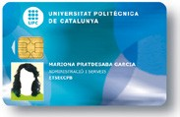Life at ETSEIB

Information student service
Demana UPC-ETSEIB

https://demana.upc.edu/etseib/?&lang=en_us
Academic service · e-Secretaria
https://prisma-nou.upc.edu/apl/home_estudiants.php?idioma=3

How can you get the access?
You will receive an email with your username and the steps to get the password.

Students should fill the option “Students ---Personal” data BEFORE the day of the enrolment
Academic intranet · Virtual Campus UPC
In there you will find all your subjects and the teachers will up-load any kind of information they consider useful for the students; as well as the grades.

https://atenea.upc.edu/login/index.php?lang=en

Students will have access in Atenea 24h after enrolment Same username and password as e-Secretaria
Student card · student ID http://www.upc.edu/identitatdigital/ca
Same username and password as e-Secretaria

1. Update your photo 2.
*A copy of the enrollment sheet can be used as a provisional student card


Computer
facilities
Other
services

Computer labs
1st and 5th floor (H building)
Free access · except during class hours Access:
- Same username and password as e-Secretaria
- Temporary ID:
  - Username: erasmus
  - PASSWORD: 2018
Printing docs
Follow the instructions at the beginning of every session in computer labs
Wifi
WIFI networks at ETSEIB – Eduroam https://serveistic.upc.edu/ca/wifiupc/documentacio/assistent-de-configuracio-per- eduroam

Students associations
Most associations are located in the H building You can check the whole list on our website
https://etseib.upc.edu/ca/lescola/associacions-destudiants
Internships in companies
Work placements while your exchange period
https://etseib.upc.edu/ca/universitat-empresa/incorporacio-de-talent/borsa-de-practiques-externes/borsa-de-practiques-externes
Library ETSEIB· http://bibliotecnica.upc.edu Opening hours: normally from 8:30 to 21h
Borrow, renew and reserve documents, multimedia material and IT equipment
Sport facilities · http://www.upc.edu/esports Sport facilities, services and clubs at:
- Gym · Building ETSEIB (basement)
- UPC Sports center · C. Jordi Girona, 3; EP Building
Photocopy service
Opposite the elevators (H building)
It provides full copying and stationary services
Bar
1st floor (H building)
Opening hours: from Monday to Friday 7:30h to 19:30h

Languages at ETSEIB

Languages
<
Language exchanges
o ESN organizes weekly language exchanges. Contact: info@esn-upc.org
ç
ñ
Catalan courses · Servei de Llengües and Terminologia ·
http://www.upc.edu/slt/en?set_language=en
c/Jordi Girona, 31, TG building. Contact: didactica.slt@upc.edu
Spanish courses
eee.cervantes.es

Other information


Accommodation
www.bcu.cat
Health service · CatSalut
- Catalan health service model integrates into a single network of public use all health resources. https://catsalut.gencat.cat/
- Private medical insurance:
https://www.upc.edu/sri/en/mobility_office/students-mobility-office/incomings/prepare-your-trip/insurance

Emergencies
Operates on a 24-hour immediate response regarding all kind of emergencies
In case of an accident,
should contact directly the insurance company

